Aerohive Networks Inc.
QA TestCase Template

Revision History
Version | Date | Author | Description
0.1 | 2008-12-16 | Zhao haihui | Initial version

Table of Contents
Glossary and Abbreviations

Introduction
We can login AP via console by default, now we can use CLI to disable console serial port, After disable console serial port, cann’t login AP via console.

Test point or strategy

Login AP via console by default

SSH login AP, disable console serial port, then try login AP via console

Console login AP, disable console serial port, then enable console serial via SSH login

Check if read-write user can disable console serial port

Check if read-only user can disable console serial port

Topology



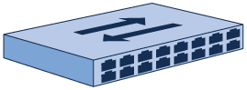

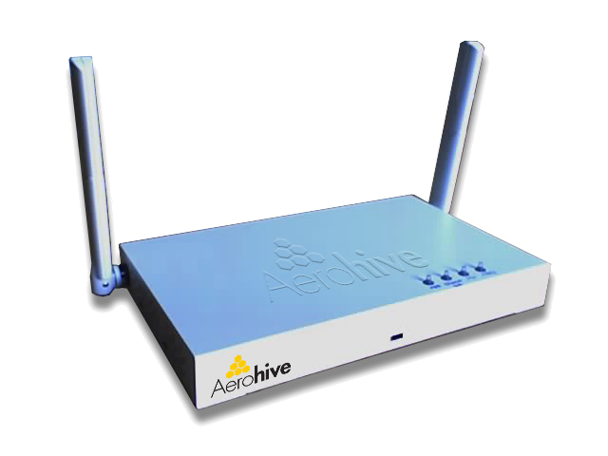

Topology 1

Test Case

FT_Console_serial_port_1
Case ID | FT_Console_serial_port_1
Priority | Accept | Automation Flag | No
Topology to use | Topology 1
Description | Login AP via console by default
Pre-condition | AP connect to switch via console and AP with default setting
Test procedure | Login AP via console
Expect result | Login AP successful

FT_Console_serial_port_2
Case ID | FT_Console_serial_port_2
Priority | Accept | Automation Flag | No
Topology to use | Topology 1
Description | SSH login AP, disable console serial port, then try login AP via console
Pre-condition | AP connect to switch via console and AP with default setting  Know AP’s ip address
Test procedure | 1. Login AP via SSH  2. Check console serial port status by show console  3. Execute “no console serial-port enable”  4. Login AP via console
Expect result | 1. Login AP successful  2. Serial port status: Enabled  3. Serial port status: Disabled  4. Login AP failed

FT_Console_serial_port_3
Case ID | FT_Console_serial_port_3
Priority | Accept | Automation Flag | No
Topology to use | Topology 1
Description | Console login AP, disable console serial port, then enable console serial via SSH login
Pre-condition | AP connect to switch via console and AP with default setting  Know AP’s ip address
Test procedure | 1. Login AP via console  2. Disable console serial port  3. SSH login AP and enable console serial port
Expect result | 1. Login AP successful  2. Could not execute any operation  3. Console login user can execute operation

FT_Console_serial_port_4
Case ID | FT_Console_serial_port_4
Priority | Low | Automation Flag | No
Topology to use | Topology 1
Description | Check if read-write user can disable console serial port
Pre-condition | Create a read-write user in AP
Test procedure | 1. Read-write user to login AP via SSH  2. Disable console serial port  3. Login AP via console
Expect result | 1. Login AP successful  2. Show console can see: Serial port status: Disabled  3. Login AP failed

FT_Console_serial_port_5
Case ID | FT_Console_serial_port_5
Priority | Low | Automation Flag | No
Topology to use | Topology 1
Description | Check if read-only user can disable console serial port
Pre-condition | Create a read-only user in AP
Test procedure | 1. Read-only user login AP via SSH  2. Disable console serial port
Expect result | 1. Login AP successful  2. Could not execute this command, suggest error

CLI (Automation Status: Yes/No)
AH-035e00#show console
Console page lines: 100
Console timeout in minutes: disabled
Serial port status: Enabled

AH-035e00#console serial-port enable
<cr>

AH-035e00#no console serial-port enable
<cr>

Customer Issue or Typical Bug

